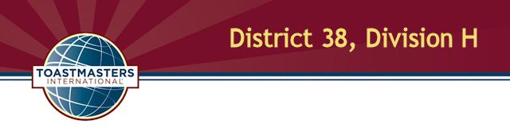
International Speech and Table Topics Contest
Wednesday, April 3, 2019
5:30 P.M. at the Giant Super Food Store

Agenda

Contest Chair Title, Name, TM credentials
Chief Judge Name, TM credentials

5:30 Registration and Refreshments

5:45 Opening
Contest chair greets attendees and announces period for contestants to prepare and submit necessary paperwork.

6:00 Briefings
Contest chair briefs contestants and has them draw for speaking positions. Chief judge briefs judges, ballot counters and timers.

6:20 Call to order
Sergeant at arms calls the contest to order and introduces the contest chair.

6:21 Welcome
Contest chair welcomes contestants, functionaries, dignitaries and guests.

6:23 International Speech Contest (5-7 min. per speaker, 1 min. between each speech)

Contestant name Speech title Order

List in alpha order title _____
List in alpha order title _____

7:04 Between-contest break (15 min.)

7:19 Call to order
Sergeant at arms reconvenes the contest and introduces the contest chair.

7:20 Table Topics Contest: (1-2 min. per speaker, 1 min. between each speech)

Contestant name Order

List in alpha order _____
List in alpha order _____

7:30 Contestant Interviews (3 min. each)
Contest chair interviews contestants.

8:00 Contest Winner Announcements
Contest chair announces contest winners.

8:30 Closing
Contest chair shares closing comments. Area and division governors share comments.

8:35 Adjournment

The contest organizers wish to thank our generous sponsors for providing the food for today's contest; we ask that in appreciation you give them your business.

Tony Roni's, Willow Grove
The Fresh Market, Welsh Road, Horsham

